Day 1: AI Fundamentals & Environment Setup
Theoretical Concepts
Already learnt!
Practical Implementation
- Download and install Python 3.11+ from python.org (verify with python --version)
I already installed python and here is the verification:
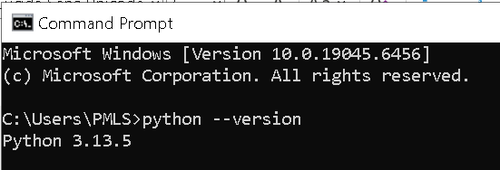
- Install VS Code from code.visualstudio.com and add Python extension.
I have already installed VS Code and added python extension in it.
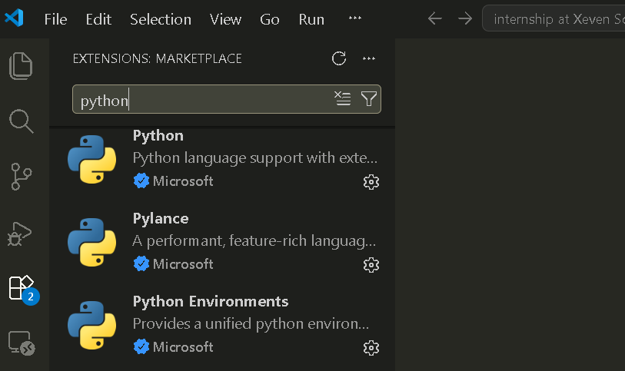

- Understanding virtual environments vs. global environments (isolation and dependency management)
Feature | Global Environment | Virtual Environment
Installation Scope | Packages are installed system-wide | Packages are installed only for one project
Shared Packages | All projects use the same packages | Each project has its own packages
Dependency Conflicts | High chance of conflicts | No conflicts between projects
Storage | Uses less disk space | Uses more disk space (separate packages)
Best For | Small experiments | Professional projects

- Install and set up UV (modern Python package installer): curl -LsSf https://astral.sh/uv/install.sh | sh

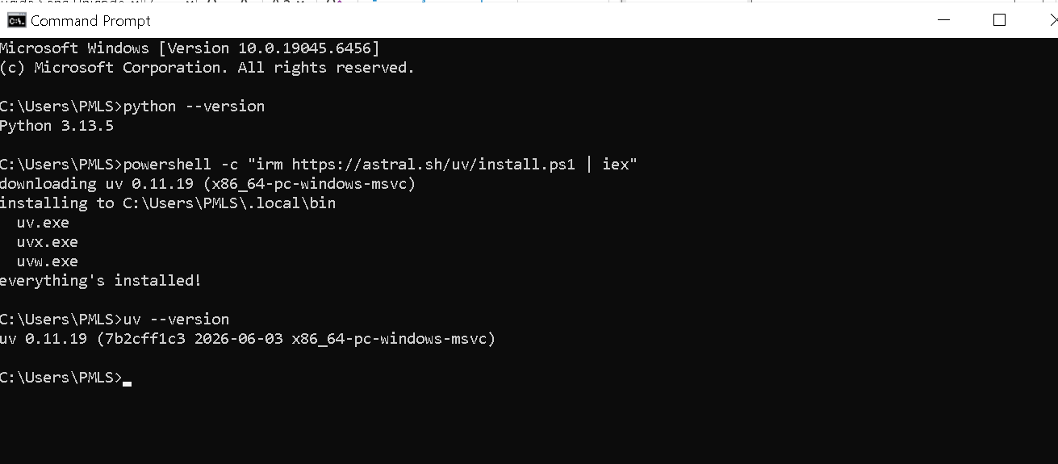
- Create project folder structure: ai-internship-xeven-2026/day01/
Created the folder structure:
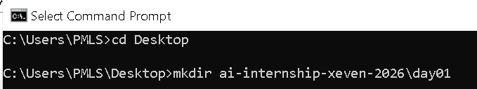
Verification:
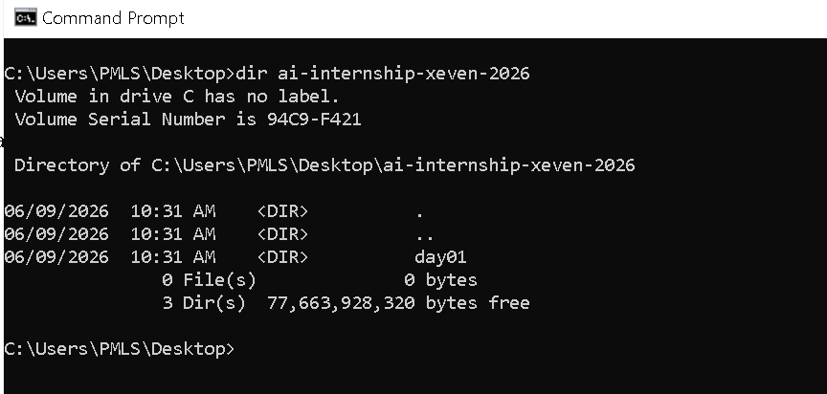
Created and activated the UV environment:

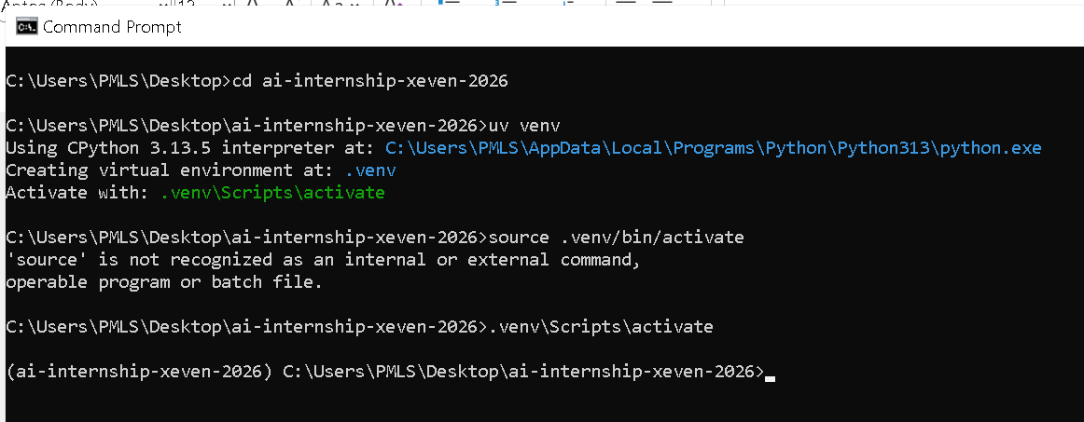

Troubleshooting:
On Windows, source .venv/bin/activate does not work because it is a Linux/macOS command; the correct activation command is .venv\Scripts\activate.

- Write first Python script: app.py with personalized greeting using print()
Here is my first python script:
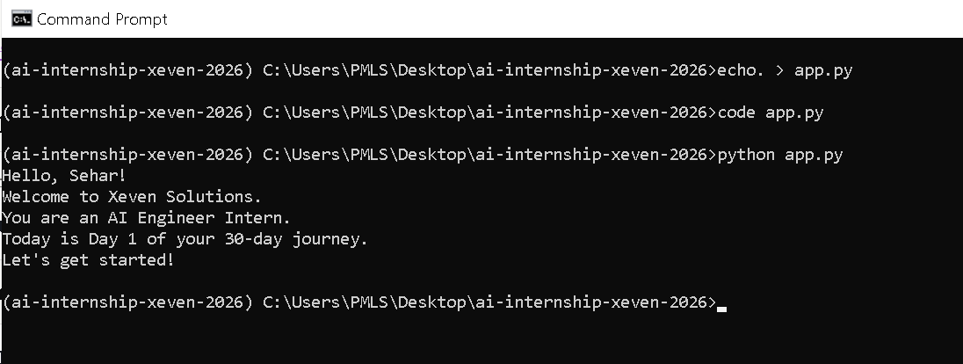
- Create GitHub account (if needed) and configure Git with name and email
Since I already have a GitHub account, so I’ll just configure Git on my computer with my name and email.
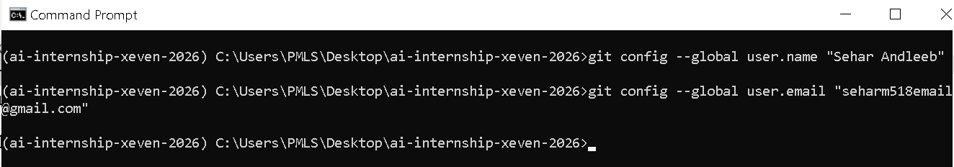
Verification:
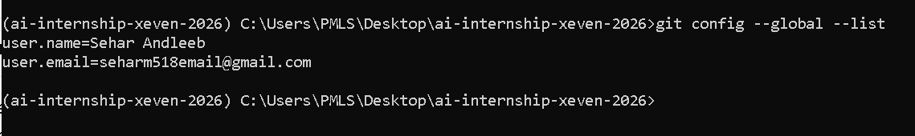

- Initialize Git repository, create .gitignore, and make first commit
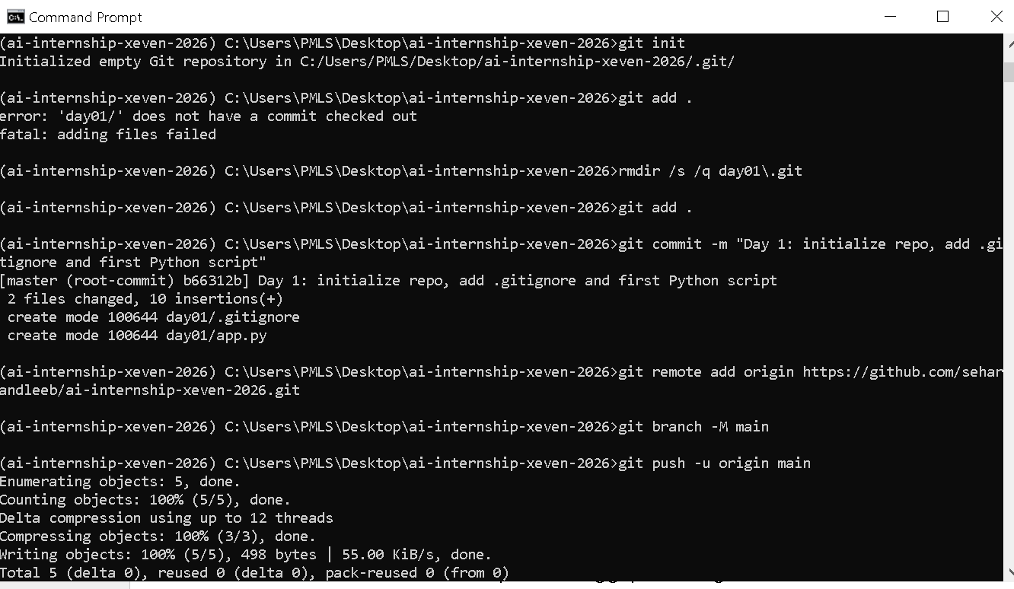
Steps I followed:
- Navigated to the root project folder “ai-internship-xeven-2026”
- Created “.gitignore” to exclude “.venv/, __pycache__/, .vscode/” etc.
- Ran git init, git add ., and made the first commit
- Connected to GitHub and pushed using git push -u origin main

Problems & Fixes:
Problem | Fix
fatal: not a git repository | Ran git init in the correct root folder
day01/ does not have a commit checked out | Removed nested .git using rmdir /s /q day01\.git
src refspec main does not match any | Made a commit first before pushing

Key Learning: Always run git init in the root folder, never inside subfolders.
- Write comprehensive README.md explaining the project
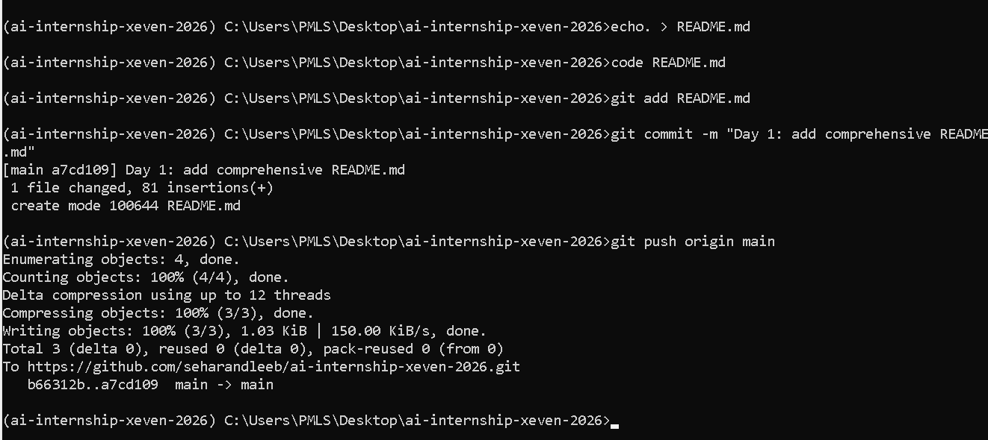

Practical Tasks
Task 01:
- Create app.py with: print('Hi, this is [Your Name], future AI engineer!')
